SINU 2.0

Project documentation

Student(s):

* Octavian-Mihai Matei

**Group: 30431**

**Contents**

I Project specification 3

1.1 Domain Model Diagram 4

II Use-Case model 5

2.1 Users and stakeholders 5

2.2 Use-Case identification 5

2.3 UML Use-Case diagram 8

III Architectural design 10

3.1 Conceptual architecture 10

3.2 Package diagram 10

3.3 Class diagram 10

3.4 Database (E-R/Data model) diagram 11

3.5 Sequence diagram 11

3.6 Activity diagram 11

IV Supplementary specifications 11

4.1 Non-functional requirements 11

4.2 Design constraints 11

V Testing 12

5.1 Testing methods/frameworks 12

5.2 Future improvements 12

VI Bibliography 12

# I Project specification

SINU 2.0 proposes a revamp of the internal online management application used by TUC-N, [websinu.utcluj.ro](https://websinu.utcluj.ro).

This project was created in order to modernize and give a new face to the above application, having varied functionalities, such as tax payment, visualization of student groups, final grading and user information modification. Moreover, a great inspiration was the application [Moodle](https://moodle.org/?lang=eng), which has a grading system, but also a material support, in order to migrate everything to a single more manageable platform.

Also, the project will have three main user groups, the administration members, teachers and the students, so it can allow for a varied and exhaustive set of actions for all the roles. The system could also allow for a mix of these roles, in order to take into account the situations of administration-teacher or teacher-student.

## Domain Model Diagram

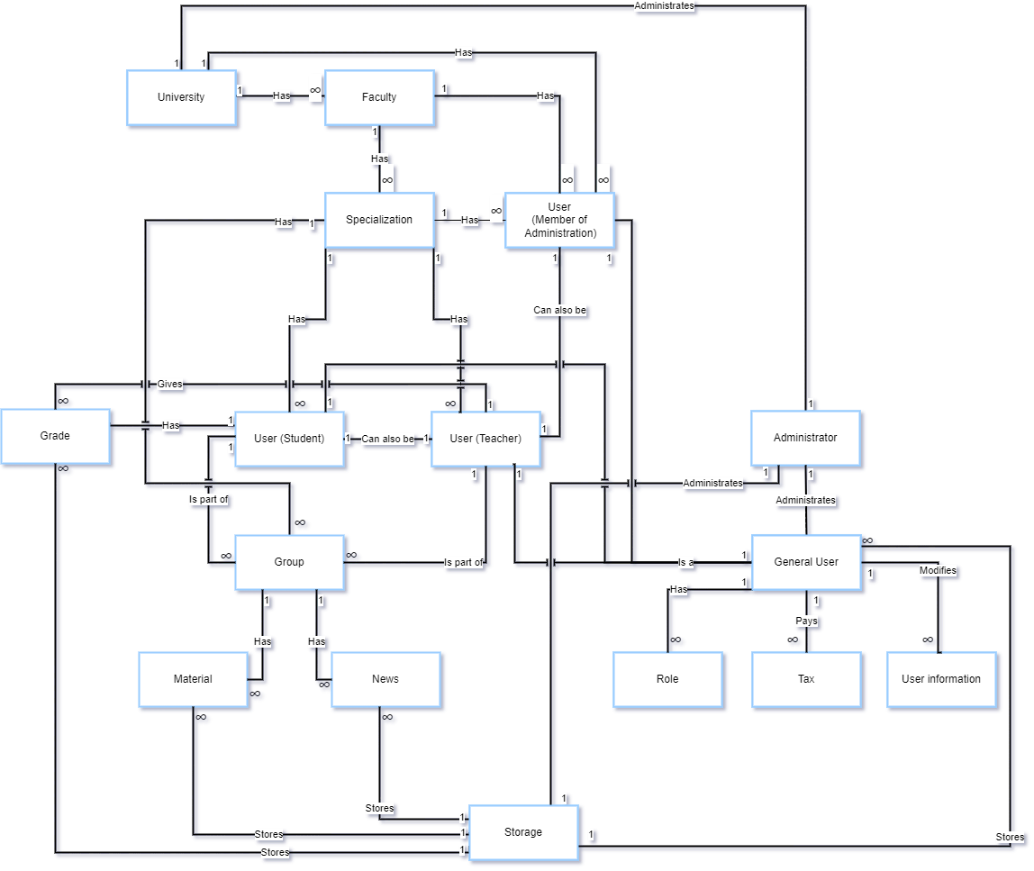

# II Use-Case model

The project will have three main user groups, the administration members, teachers and the students, so it can allow for a varied and exhaustive set of actions for all the roles. The system could also allow for a mix of these roles, in order to take into account the situations of administration-teacher or teacher-student. Another user would be the general admin, the one which administrates all the university, role given only to the university rector and possibly some administration members, in order to make a smooth continuity.

## 2.1 Users and stakeholders

* ***users***​
* Student
* Teacher
* University/Faculty Administration member
* Platform administrator
* ***stakeholders***​
* Project Manager/ Developing Team/ Manager - Octavian-Mihai Matei
* Project Manager/ Consultant - Alexandru Frasie
* Competition – Websinu, Moodle

## 2.2 Use-Case identification

**__________________________________________________________________**

**Use case name:** Post news

**Level:** A user posts news on the news feed of the group

**Main actor:** Teacher

**Main success scenario:**

The teacher accesses the platform, then they login, access the group and choose the option to post news on the news feed of the group. They write the message, optionally upload a picture or/and document and then they post it. After this flow of actions, all the participants of the group should be able to visualize the new feed.

**Extension:**

When the teacher uploads the image and/or the document, the file could have the wrong extension or size, so the platform warns the user about this.

**__________________________________________________________________**

**Use case name:** Pay a tax

**Level:** A user pays a university tax

**Main actor:** General User

**Main success scenario:**

The user accesses the platform, logs into it and then accesses the taxes option from the menu. They are presented with a variety of tax options such as dorm payment, language test, parking on the university’s premises etc. They select the necessary options and then press the “Pay” button. The user inserts the card data and a successful message is displayed with confirmation on email.

**Extension:** NaN

**__________________________________________________________________**

**Use case name:** Give grades

**Level:** A user gives grades to the students registered in the group

**Main actor:** Teacher

**Main success scenario:**

First, they will login, then access the respective group. After this, the teacher will register the grade for a specific student, with optional feedback option. These grade and feedback will be available for the student to see.

**Extension:**

If the student retakes the evaluation, then a modification or addition to the grade system can be made.

**__________________________________________________________________**

**Use case name:** Create new teacher account from existing account database

**Level:** An administration member user promotes a student account to a teacher account

**Main actor:** Member of administration

**Main success scenario:**

First, they will login, then access the management page of teachers and select to add another educator. Then they will search for the account’s email and name in order to find the user. After this, the account will have double role, one of a student and one of a teacher.

**Extension:**

If the email and name combination is wrong, an error will be displayed

**__________________________________________________________________**

**Use case name:** Add users to group

**Level:** A teacher will add users with different roles

**Main actor:** Teacher

**Main success scenario:**

First, they will login, then access the group page. They will have the rights to modify the group, so they will access the addition portion of the page and select the email and the role of the new user in the group.

**Extension:**

If the email and name combination is wrong, an error will be displayed.

The roles of the user can be:

* If the new user is only a student, then the role can only be student.
* If the new user is only a teacher, then the role can only be teacher.
* If the new user is both a student and a teacher, then the role can be either a teacher or a student.

## 2.3 UML Use-Case diagram

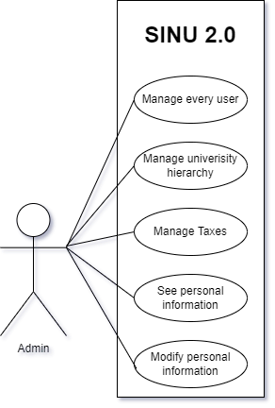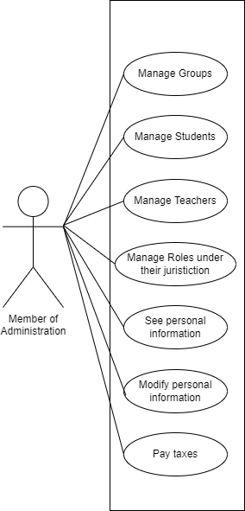

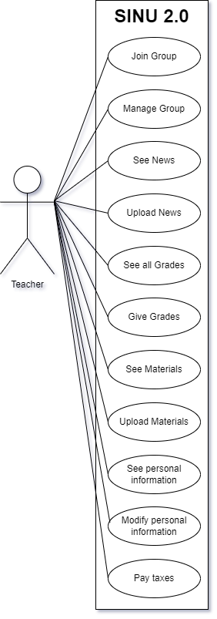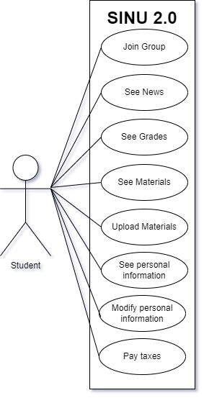

# III Architectural design

*< Se va scrie o mica introducere./>*

## 3.1 Conceptual architecture

*<In acest capitol se vor prezenta arhitectura proiectului. Este o aplicatie web sau desktop. Are baze de date? Cate componente are? Client-Server? etc*

*/>*

## 3.2 Package diagram

*< (Package Diagram)/>*

## 3.3 Class diagram

*< (Class Diagram)/>*

## 3.4 Database (E-R/Data model) diagram

*< (Data Model)/>*

## 3.5 Sequence diagram

*< (Sequence Diagram)/>*

## 3.6 Activity diagram

*< (Activity Diagram)/>*

# IV Supplementary specifications

*< Se va scrie o mica introducere./>*

## 4.1 Non-functional requirements

*< Specificatiile non-functionale ale aplicatiei. Se va discuta la laborator./>*

## 4.2 Design constraints

*< Se va discuta la laborator./>*

# V Testing

*< Se va discuta la laborator./>*

## 5.1 Testing methods/frameworks

## 5.2 Future improvements

# VI Bibliography